МИНИСТЕРСТВО ОБРАЗОВАНИЯ РЕСПУБЛИКИ БЕЛАРУСЬ

УЧРЕЖДЕНИЕ ОБРАЗОВАНИЯ

“БРЕСТСКИЙ ГОСУДАРСТВЕННЫЙ ТЕХНИЧЕСКИЙ УНИВЕРСИТЕТ”

**ИНТЕЛЕКТУАЛЬНЫЕ ИНФОРМАЦИОННЫЕ ТЕХНОЛОГИИ**

ОТЧЁТ

По лабораторной работе № 2

Выполнил:

Студент группы ИИ-22

Копанчук Евгений Романович

Проверил:

Рыжов А. С.

Брест – 2023

**Ход работы**

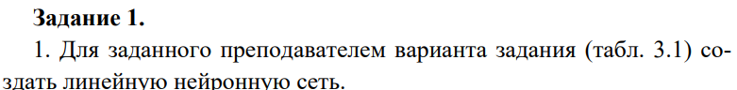





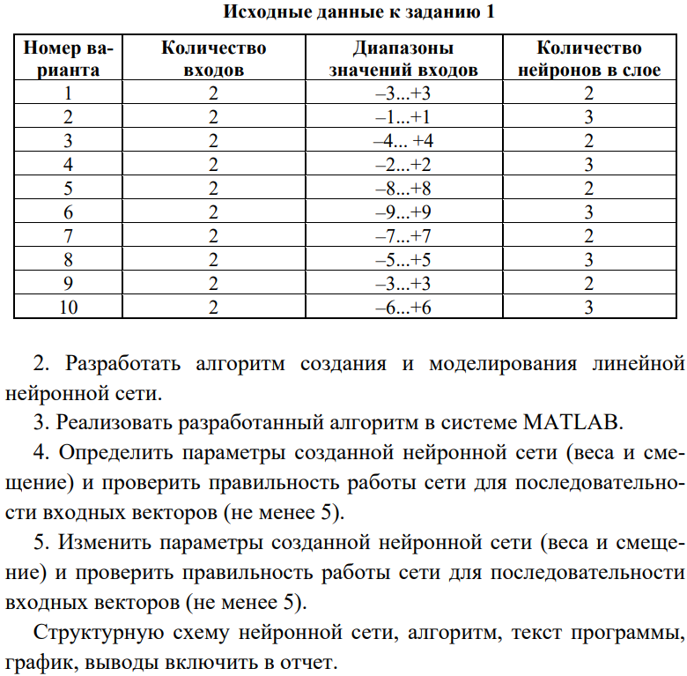

|  |  |
| --- | --- |
| >> clear, net = newlin([-2 2; -2 2], 2);  >> net.IW{1,1}, net.b{1}  ans = 0 0  0 0  ans = 0 0  >> sim(net, [-7; -7])  ans = 0 0  >> sim(net, [-7; 7])  ans = 0 0  >> sim(net, [7; -7])  ans = 0 0  >> sim(net, [7; 7])  ans = 0 0  >> sim(net, [0; 0])  ans = 0 0  >> net.IW{1,1} = [[2; 3], [1; 4]];  >> net.b{1} =[-4; 4]  >> sim(net, [-7; -7])  ans = -25 -45  >> sim(net, [-7; 7])  ans = -11 11  >> sim(net, [7; -7])  ans = 3 -3  >> sim(net, [7; 7])  ans = 17 53  >> sim(net, [0; 0])  ans = -4 4  >> | net =  Neural Network  name: 'Custom Neural Network'  dimensions:  numInputs: 1  numLayers: 1  numOutputs: 1  numWeightElements: 6  sampleTime: 1  connections:  biasConnect: true  inputConnect: true  layerConnect: false  outputConnect: true  subobjects:  input: Equivalent to inputs{1}  output: Equivalent to outputs{1}  inputs: {1x1 cell array of 1 input}  layers: {1x1 cell array of 1 layer}  outputs: {1x1 cell array of 1 output}  biases: {1x1 cell array of 1 bias}  inputWeights: {1x1 cell array of 1 weight}  layerWeights: {1x1 cell array of 0 weights}  weight and bias values:  IW: {1x1 cell} containing 1 input weight matrix  LW: {1x1 cell} containing 0 layer weight matrices  b: {1x1 cell} containing 1 bias vector |

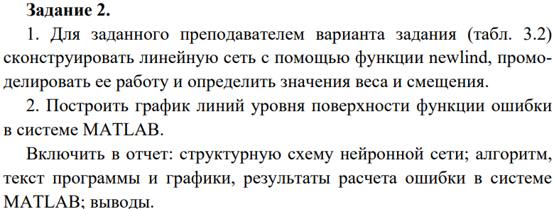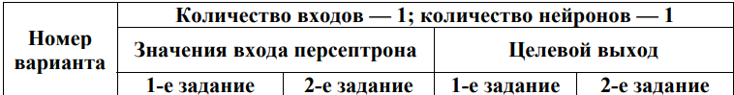

|  |  |
| --- | --- |
| >> P = [-2 0];  >> T = [1 1];  >> net = newlind(P, T);  >> net.IW, net.b  ans =  1×1 cell array  {[0]}  ans =  1×1 cell array  {[1]}  >> Y = sim (net,P)  Y =  1 1  >> |  |

|  |  |
| --- | --- |
| >> P = [-2 0 2 -2];  >> T = [1 1 -1 -1];  >> net = newlind(P, T); |  |

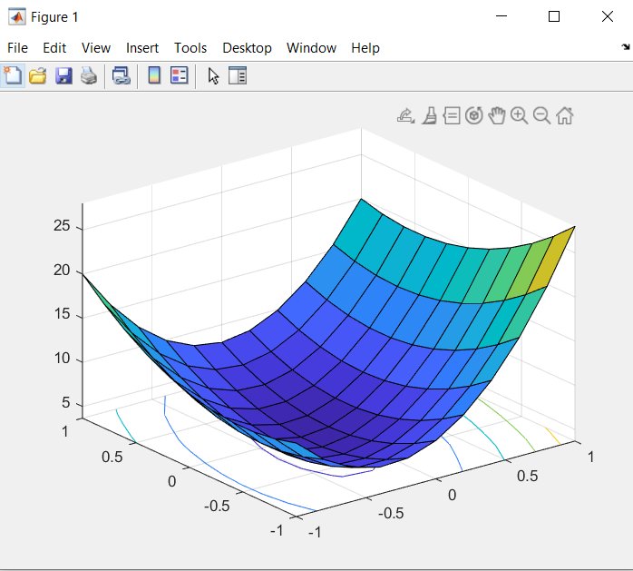

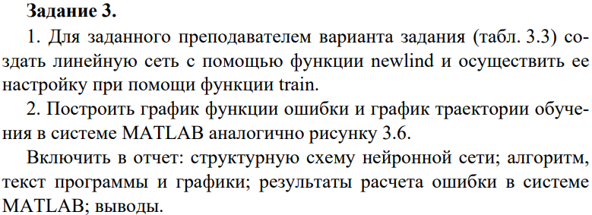

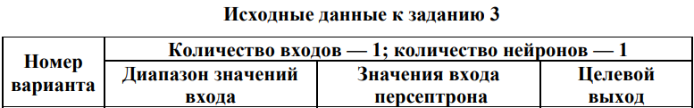

|  |  |
| --- | --- |
| >> clear, net = newp([-2 2],1);  P = [0 1];  T = [0 1];  >> net.trainParam.goal = 0.001;  net.trainParam.epochs = 100;  >> [net, tr] = train(net,P,T)  >> w_range=-1:0.2:1; b_range=-1:0.2:1;  ES = errsurf(P,T, w_range, b_range, 'purelin');  >> surfc(w_range, b_range, ES) |  |

